Total Marks:
Obtained Marks:

LAB: Artifiical Intelligance

Lab Task # 03

Last date of Submission: Oct 8th, 2025

Submitted To: Mam Mutahra Khalid Butt
_______________________________________________________________________________________________________________________________________________________________________________________________________________________________________
Student Name: Ubaid Bin Waris
_______________________________________________________________________________________________________________________________________________________________________________________________________________________________________
Reg Number: 2212416
_______________________________________________________________________________________________________________________________________________________________________________________________________________________________________

Activity No.1

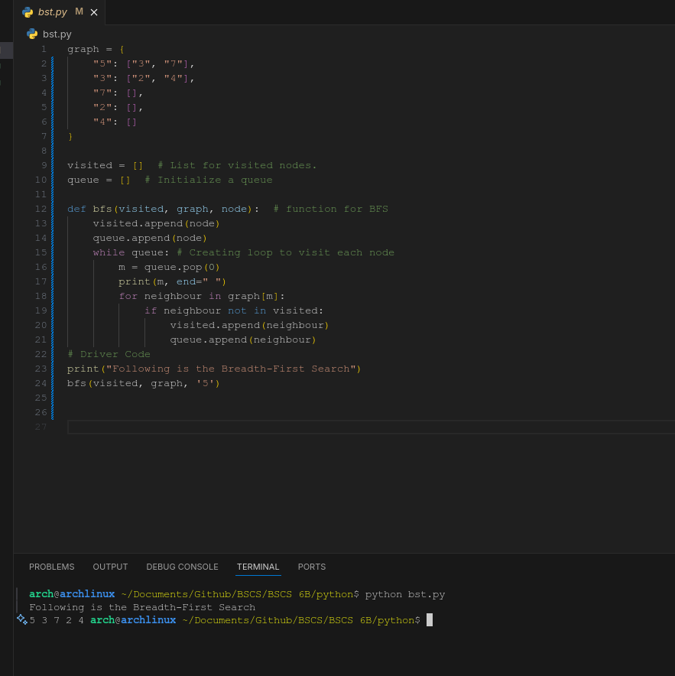

Activity no.2

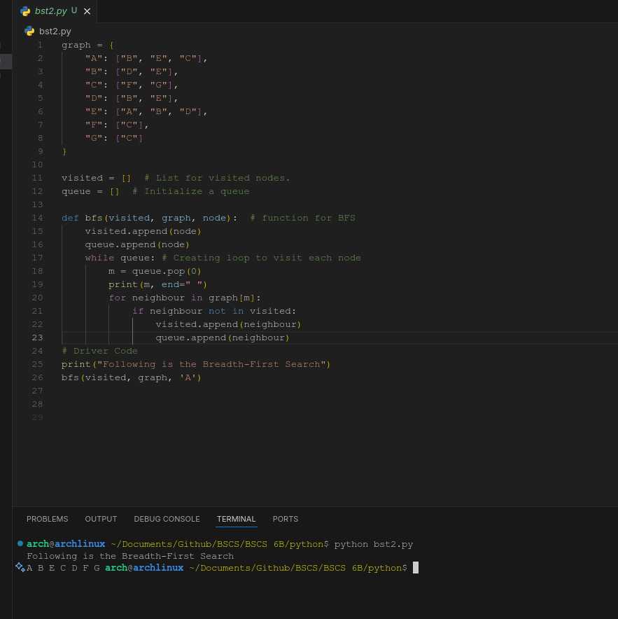

Activity no.3

